Module-3(HTML-5)

Q1: What are the new tags added in HTML5?
Ans: Html-5 introduced several new tags that provide better structure and improved functionality.
- <nav>: Represent a section of navigation.
- <footer>: Represent a footer section of a document section.
- <video> and <audio>: Use to add audio and video content in html document file.
- <Section>: Use to define a specific section in a web page.
- <mark>: Use to mark or highlight the specified content with background color.
- <dialog>: use to include dialog box in webpage.

Example of html-5 tags:
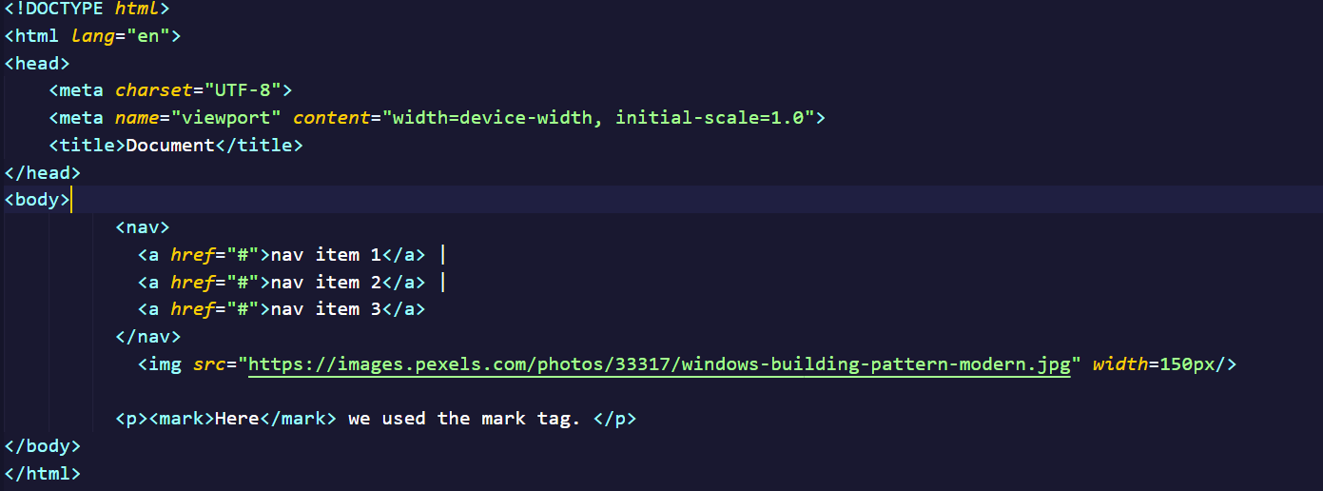

Output: 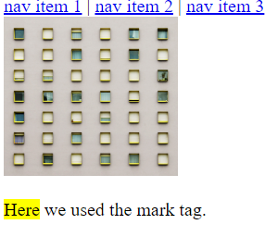

Q2: How to embed audio and video in a webpage?
Ans: Audio: Use the <audio> tag and specify the ‘src’ to embed video in web Page.
Example:
<audio src=”src” controls autoplay></audio>
Video: Use the <video> tag and specify the ‘src’ to embed video in web Page.
Example:
<video src=”src” controls autoplay></video>

Q3: Semantic element in HTML5?
Ans: Semantic elements in html-5 are tags that provide meaning and structure to the content of a web page.
Here some semantic elements given below:
1.<header>: Represent header content of a web page.
2.<nav>: Defines a section of navigation links.
3.<main>: Represent the main content of the document.
4.<section>: Define stand alone section with related content.
5.<time>: Specifies a specific time
6.<figure>: Represents self-contained content, such as an image, screen shot etc.
7.<figure caption>: Provide a caption or description for given content in <figure>.

Example: 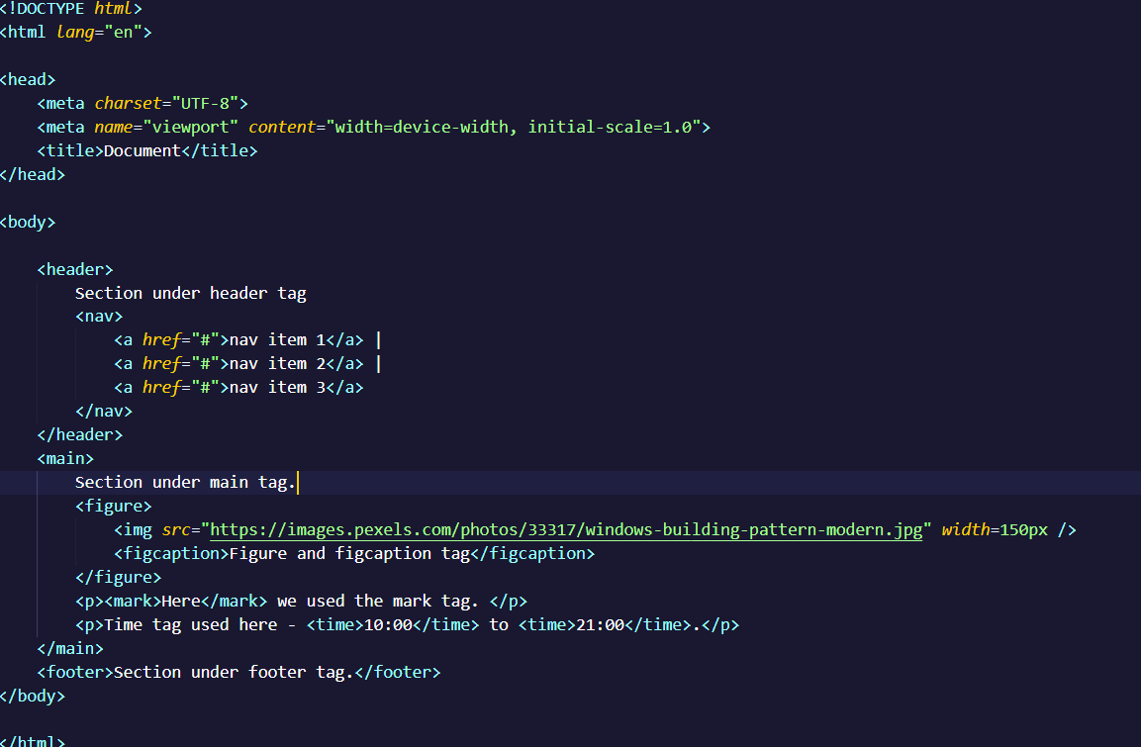

Output: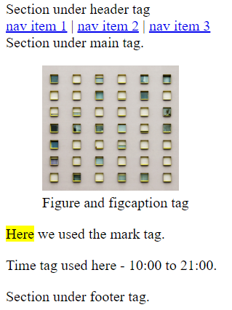

Q4: Canvas and SVG tags
Ans: SVG: SVG stands for scalable vector graphics. SVG image are resolution-independent and can be scaled without losing image quality.
The <svg> tag is an xml-based vector graphics format that allows for creation scalable 2D vector graphics. It uses XML syntax to define paths, and other graphical elements.

Example:
<svg width="500" height="300">
<rect x="0" y="0" width="200" height="200" fill="red"></rect>
</svg>

Canvas: The canvas tag is used to draw graphics, on the fly via java script. The canvas tag is transparent, and is only for container graphics, you must use a script to actually draw the graphics.
Example:
<canvas> This is a canvas tag </canvas>

